SUMMARY REPORT FOR THE MODEL, THE SIMULATION OUTCOMES

From the finding in the multivariate model that uses multi variate multiple linear regressions on multiple variables to model a regression model for my outputs, it is observed that:

Life expectancy is generally higher in developed countries than it is in developing countries as shown in the output below.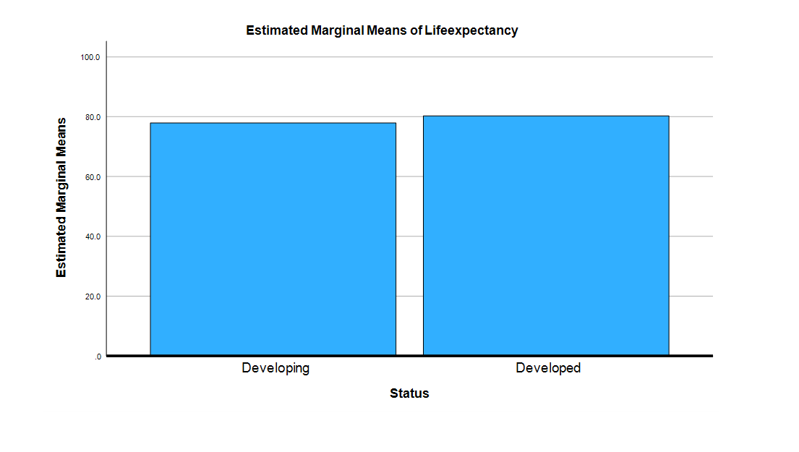

Life expectancy is seen to increase generally in countries with a higher GDP

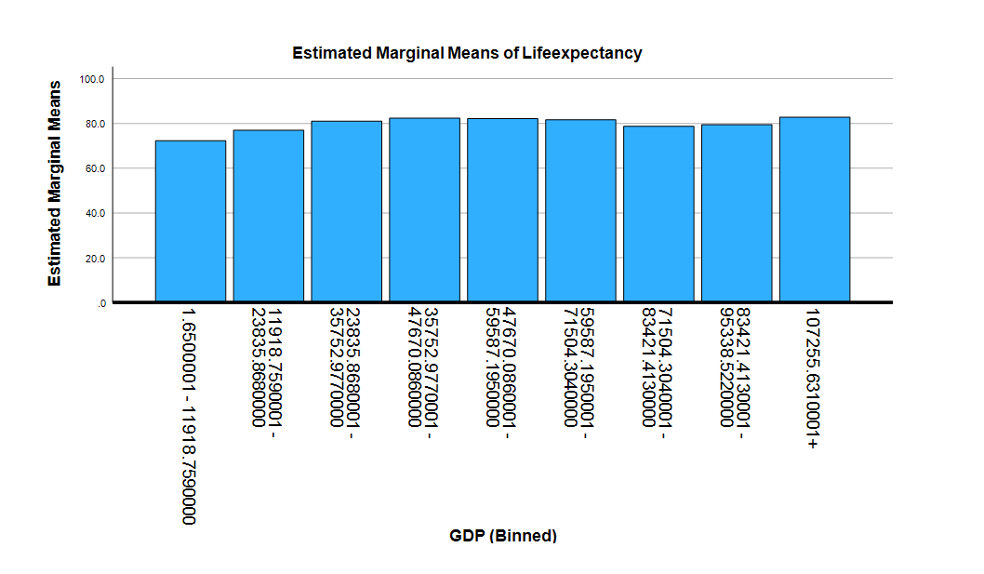

In the below, the population of the country doesnt have much of a correlation with the life expectancy of that given country.

Based on the below output, the model predicts a reasonable error bound to the actual values.

|  |  |  |
| --- | --- | --- |
|  | Life Expectancy | |
| Country | **Actual Value** | **Predicted Value** |
| Afghanistan | 65 | 66.89 |
| Albania | 73 | 66.89 |
| Argentina | 75.4 | 73.35 |